Unit 1: Lesson 6
Success and Happiness

Story:
Anne Marie flashed across the finish line, slowed down a bit, and stepped to the side to clear a way for the other runners. Then she broke into a wild dance of joy, waving her arms, jumping up and down, and shouting, “I did it! I did it! Can you believe it? I did it!”
Anne Marie had run her first Fun Run, placing in the top third of the runners. Her time was fast, too, her personal best!
Mom and Dad, Aunt Louise and Sam were waiting for her on the grass, cheering and screaming. “Way to go, Anne Marie!” She saw her family and ran over to them. “We’re so proud of you.” They were laughing and hugging, celebrating her big moment. Anne Marie couldn’t stop smiling.
“I feel great,” Anne Marie beamed. “I knew I could do it,” she said. “I feel so good about myself; I could run another race backwards!” Everybody laughed. Sam gave her the bottle of water he’d been saving for her.
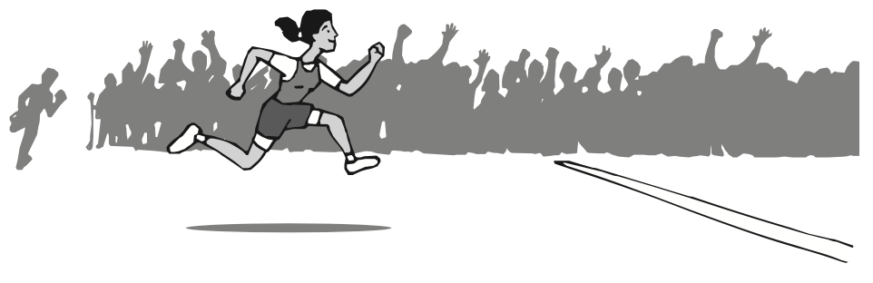

We all have our dreams of success and happiness. Some of us dream of running a marathon, writing a best-seller, or being the president. Other people dream of getting a great education, building a house, or owning a business. They may dream of working hard, having friends and family close or being a fabulous chef!
In the Positive Action program, success and happiness are one and the same. Success and happiness are both defined as feeling good about who we are, what we are doing, and how we treat others. Success and happiness are the result of choosing positive thoughts, doing positive actions, and feeling good about ourselves.
Some people think that having fancy cars and a great house is success and happiness. Others think that being famous or having a lot of power means success and happiness. Sometimes people focus on getting external things – money, power, popularity, or possessions – and forget that feeling good about themselves is an inside job. We don’t have to look very far to find someone who has all those things yet doesn’t feel successful or happy.
We are all special and unique. Our talents and our choices are different, but all of us can be successful and happy. We achieve success and happiness when we feel good about who we are, what we are doing, and how we treat others. The good feelings of success and happiness are internally motivating and help us to practice more positive actions.
Everything we have been learning in this unit has been bringing us to an understanding of the definition of success and happiness. We have learned that our self-concept is how we think and feel about ourselves. And we have learned that the main idea of the Positive Action program is that we feel good about ourselves when we do positive actions.
Then we learned how that idea works by studying the Thoughts-Actions-Feelings Circle. We saw how our thoughts lead to our actions and how our actions lead to how we feel about ourselves. When our positive thoughts lead to our positive actions, we feel good about ourselves. That’s a Happy Circle!
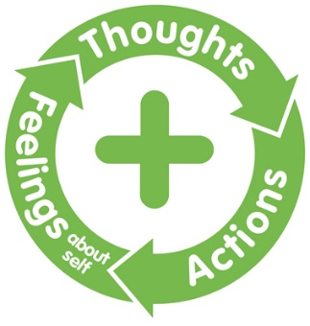
When Anne Marie ran her race, she knew she was both successful and happy. She felt good about who she was and what she was doing even while she was lacing up her sneakers that morning. Anne Marie would have been successful and happy even if she had not placed so well. She was being her best when she was doing what she loved to do. Just as Anne Marie was successful and happy, we can be, too. By finding and doing what we love to do, we will feel good about who we are and what we’re doing. Let’s get started on our road to success and happiness!

Questions:
- What is success and happiness?
- How does success and happiness come to us?
- What are some external things that we sometimes think will make us successful and happy?
- Will they actually make us successful and happy? Why or why not?
- What internal motivation leads us to do the positive actions that cause us to be successful and happy?
- What makes you feel successful and happy?
- Why does doing your best help you feel happy and successful?
- What actions do you do that make you feel successful and happy?
- How can doing what you really love to do help you be successful and happy?
Now let’s identify a particular positive action that makes you feel good about who you are, what you are doing, and how you treat others, and then make a plan to do it. Are you a good cook? Are you good at math? Do you know how to fix things? Choose a positive action that you are good at and makes you feel good about who you are and what you are doing. Make a plan to do it. You will experience what success and happiness feels like for you!
parent positive actions

Ask yourself: What does it mean to you to be happy and successful as a parent? What positive actions can you do to feel good about who you are and what you do as a parent? How can you teach your children to lead happy and successful lives?
Plan and Do: Practice one positive action for each of your children that would make you feel successful and happy as a parent. Maybe you could spend extra time reading to your children or take each child out for a special treat. Focus on the good feelings you have about yourself as a parent, when you feel good about who you are and what you do.

FAMILY POSITIVE ACTIONS
Discuss:
- How would we define a happy, successful family?
- What are some positive actions we could take to feel successful and happy as a family?
- How does it help the family when we support one another in doing the things that make each of us feel success and happy about the family?
- How can we help one another do our best?
Let’s plan to do positive actions that make us feel successful and happy as a family. Think about the things we do best as a family, the things that make us happiest. Whether we love to be outdoors, enjoy exercising together, or make beautiful music together, let’s identify something we can do that will make us feel good about who we are, what we do, and how we treat others (successful and happy) as a family.
Discuss what you can do as family. Make a plan and do it!

COMMUNITY POSITIVE ACTIONS
A good way to be successful and happy in our community is to take part. Let’s think of an activity or event in our community that would make us feel successful and happy if we participated, and then let’s get involved. Perhaps we could offer a few hours of community service.
Let’s find some way to improve our community by sharing what makes us feel good about who we are and what we are doing. As we contribute our best to the community, we can watch the ripple effect of our positive actions on others. If each member of a community is happy and successful, then the community is happy and successful.

SUMMARY
We all have our dreams of success and happiness. Sometimes those dreams include making a lot of money, having fame or power, raising a healthy, happy family. Sometimes we can achieve those things, and sometimes we can’t. But we can all be successful and happy!
Anne Marie’s dance at the end of her race was a dance of success and happiness. Success and happiness are one and the same thing: feeling good about who we are, what we are doing, and how we treat others. Anne Marie was successful and happy because she felt good about who she was and what she was doing.
We’re all special, unique people with dreams of our own success and happiness. Our talents and our choices are different, but we can all be successful and happy. All of us can do the positive actions that we love to do.
There’s an effective way for each one of us to achieve the success and happiness we want. It comes by thinking positive thoughts, doing positive actions, and enjoying the positive feelings we get about ourselves. The very best contribution we can make to others is to lead a successful, happy life. We are successful and happy when we feel good about who we are, what we are doing, and how we treat others.
We can all dance at the end of our race. And we can also be successful and happy along the way.

Word of the Week: Success
To feel good about who you are, what you are doing, and how to treat others.

